DIS-Asia-Indus-Bowl-Fish design

# 

# 

# indus valley zoomorphic bowl c.3300-1300BC •Indus valley bowl •Bronze age period circa 3300-1300 BC •Painted Zoomorphic fish design •Excellent condition Dimensions Height: 6.2cm Width: 8.9cm (top rim) Weight: 126.1g

# sPšo

# Order details

## Sales order

Sold by [sussex-antiquiti...](http://myworld.ebay.com/sussex-antiquities) ( [2029](http://feedback.ebay.com/ws/eBayISAPI.dll?ViewFeedback&userid=sussex-antiquities) )

### Delivery package 1 of 1

Estimated delivery Friday, May 20, 2016 - Tuesday, May 31, 2016

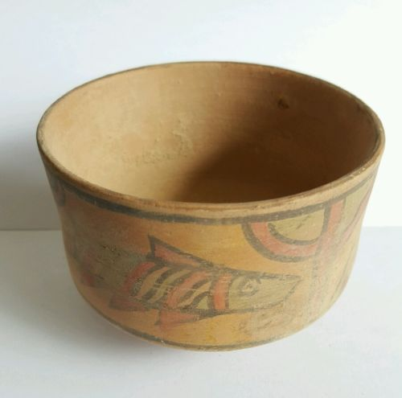

#### [Beautiful Ancient bronze age indus valley zoomorphic fish bowl c.3300-1300BC](http://www.ebay.com/itm/162057587586)

|  |  |
| --- | --- |
| Item price | GBP 40.00 |
| Quantity | 1 |
| Item number | 162057587586 |
| Shipping service | Royal Mail International Signed |

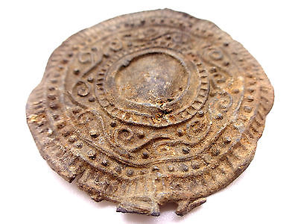

#### [Ancient Roman Votive patterned Lead Mirror 2-4th Century AD](http://www.ebay.com/itm/151569824365)

|  |  |
| --- | --- |
| Item price | GBP 30.00 |
| Quantity | 1 |
| Item number | 151569824365 |
| Shipping service | Royal Mail International Signed |

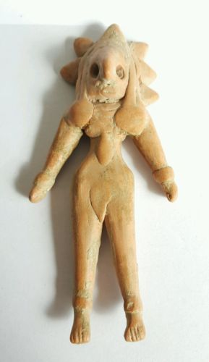

#### [Rare Ancient bronze age indus valley fertility idol c.3300-1300BC](http://www.ebay.com/itm/152076144221)

|  |  |
| --- | --- |
| Item price | GBP 110.00 |
| Quantity | 1 |
| Item number | 152076144221 |
| Shipping service | Royal Mail International Signed |

## Shipping address

Ralph J Coffman Jr

149 Atlantic Ave

Swampscott MA 01907-2427

United States

## Order total

|  |  |
| --- | --- |
| Subtotal | GBP 180.00 |
| Shipping | GBP 29.85 |

**Total**

GBP 209.85

Order placed on

Wednesday, May 11, 2016

Payment method

PayPal

Payment date

Wednesday, May 11, 2016